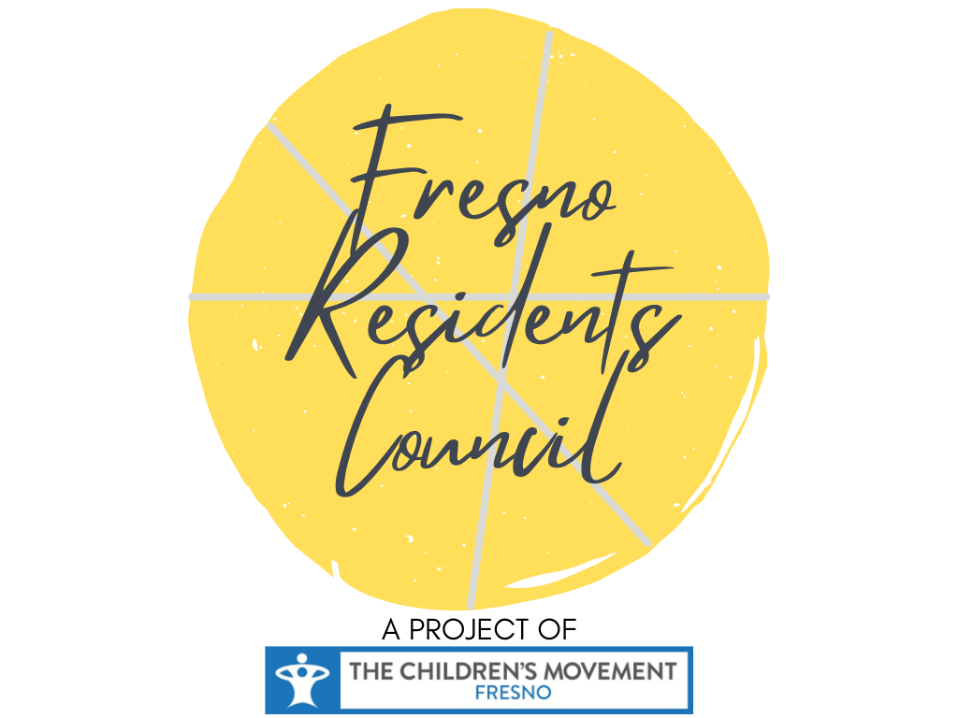

**Lub Rooj Sib Tham Hauv Zej Zog**

**(RESIDENT SUMMIT)**

**Cov Tswj Saib Xyuas Neeg Zej Zog (Resident Council Member)**

**23 Lub Xya Hli, 2021**

**Cov Txheej Txheem (Contents)**

1. Daim Ntawv Tos Txais (Letter of Acceptance) Ntawm Cov Tswj Saib Xyuas Neeg Zej Zog
2. Ntsiab Lus (Overview) Ntawm Qhov Chaw Tswj Xyuas Neeg Zej Zog Haum Fresno
3. Kev Qhia Txog Bill.com Ib Qib Zuj Zus (Step-by-step)
4. Lub Sij Hawm Kawm (Training Schedule-Tej Zaum Kuj Muaj Kev Hloov Pauv)
5. Tshwj Xeeb (Notes)

**Qhov Chaw Saib Xyuas Neeg Zej Zog Fresno Yog Dab Tsi?**

**Keeb Kwm & Tsiab Lus (Background Info & Overview):**

Kev Vam Meej Ntawm Cov Me Nyuam (The Children’s Movement or TCM) muaj zeem muag (envisions) txog lub neej pem suab uas muaj kev vaj huam sib luag zos uas los ntawm cov neeg haum zej zog (community Resident), cov koom haum, thiab cov thawj coj ntawm lub nroog Fresno kom muab cov me nyuam yaus cov kev noj qab haus huv saib pom ua nqi tseem ceeb ntawm txhua2 txoj kev txiav txim siab. TCM ua hauj lwm raws txoj cai ntawm Cradle 2 Career (C2C). TCM muab kev saib siab rau kev tsim kho ntawm cov txheej txheem (system) thiab hloov pauv cov me nyuam (thiab lawv tsev neeg) uas yog qhov tseem ceeb ntawm txhuas txoj kev txiav txim siab thiab kev muaj kev koom tes ntawm cov neeg zej zog rau txoj kev txiav txim siab.

Lub hom phiaj yog tsim kho kom sawv daws muaj kev muaj yeej (win-win policy change), hloov kho txheej txheem thiab kev sib koom kev txiav txim siab uas yuav los daws cov teeb meem uas tshwm sim rau cov me nyuam haum nroog Fresno. Kev siv zog (effort) yog txhawm rau kev tsim Rooj Sab Laj haum Zej Zog (Community Congress) cov uas yuav los txiav txim (piv txwv li: cov neeg ua hauj lwm los ntawm kev teeb tsa, cov thawj coj tsoom fwv, tus tsawj saib xyuas tsev kawm haum nroog thiab cov thawj coj hauv zej zog) thiab cov neeg nyob haum cheeb tsam (Cov neeg uas nyob haum zej zog zoo ib yam li NEJ) yuav tuaj koom nrog kev muaj kev txiav txim seb uas yuav tsim kho cov txheej txheem (piv txwv. Kev siv nhiaj ntawm zej zog, kev kawm, kev cai, thiab kev txhim kho txheej txheem) uas muaj kev cuam tshuam rau cov me nyuam ntawm lub nroog Fresno.

**Cov Hauj Lwm Pab Kom Cov Neeg Zej Zog Muab Kev Koom Tes Thiab Kev Txhawb Nqa (REAP)**

Peb muaj kev cia siab tias yuav ua tiav Cov Hauj Lwm Pab Kom Cov Neeg Zej Zog Muab Kev Koom Tes Thiab Kev Txhawb Nqa (Resident Engagement and Advocacy Program) los sis hu luv2 tias REAP. REAP yog ib qho kev rau siab uas mauj nrog cov zej zog (community based organizations or CBOs) muaj kev mob siab txog kev muaj feem xyuam txog kev sib tham ntawm kev cai lij choj nyob rau lub nroog Fresno. Peb muaj kev ntseeg ib yam nkaus xws li kev sib tham txog kev cai lij choj, nrog rau kev Ywj Pheej, kev vam meej thiab kev koom tes los ntawm cov neeg zej zog tuaj koom kev txiav txim siab txhawm rau txhim kho lawv cov zej zog (shaping their local communities).

Peb yuav ua tiav lub hom phiaj no los ntawm kev teeb tsa qhov chaw sib tham uas muaj cov neeg zej zog ntau qhov chaw ntawm lub nroog Freshno tuaj, uas yuav muaj kev sib hais, sib tham, tawm tswv yim, thiab txhawb nqa kev daws teeb meem tau zoo. REAP Anchor CBOs yuav zoo yam li txoj kev xaiv thiab txhawb nqa cov neeg ua hauj lwm ntawm neeg zej zog thiab yuav qhia txog kev muaj ntau haiv neeg nyob rau haum zej zog. Peb lub hom phiaj: yuav tsum ua kom paub tau tias cov txheej txheem kev cai tau muab teeb tsa los ua kom cov me nyuam tau kev noj qab nyob zoo.

**Cov kev saib xyuas tshwj xeeb ntawm cov tswj cov neeg zej zog (Residents) muaj xws li:**

* Rau siab (Commitment) yuav koom cov kev kawm ntawm kws tswj cov neeg zej zog uas suav yog tag nrho 6 zaus txij li thaum lub Yim Hlis xyoo 2021 thiab lub Ib Hlis xyoo 2022.
* Yuav tuaj koom txhua lub rooj sib tham kom kawg paus kawg ntsis
* Yuav rau siab rau kev sib tham kom yammuaj txiaj ntsig. Kev sib tham qee yam kuj yog tsis yooj yim kiag li (challenging); qhov tseem ceeb ces yog peb tseem qhib ...
* Rau npe haum Bill.com kom tiav txhawm rau thiaj tau txais kev them nyiaj (receive payment

**Kev siv Bill.com txhawm rau tau txais kev them nyiaj**

**VIDEO:** [**https://help.bill.com/hc/en-us/articles/360035897052**](https://help.bill.com/hc/en-us/articles/360035897052)

**Siv nrog rau (Connect) kev caw los ntawm koj tus customer**

1. 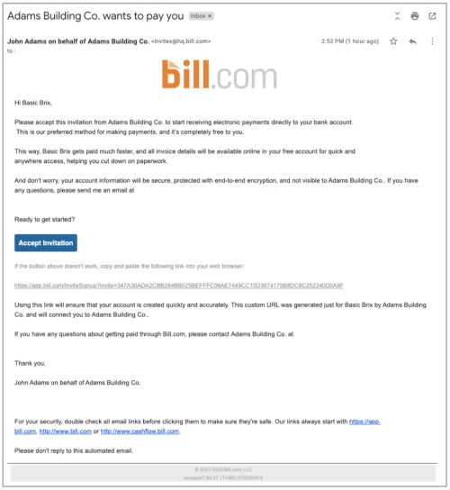Nyob haum daim ntawv caw, taum mus rau **Txais** (**Accept Invitation)**
2. Sau koj lub npe thiab lub xeem, tsim tus password, thiab taum rau (**Create account)**
   * Koj li chaw nyob email yuav raug npaj ua ntej raws li qhov chaw nyob ntawm kev caw, nws tsis tuab yeem yuav hloov tau. Tom qab uas koj nkag mus tag lawm, yog tias koj xav hloov koj li chaw nyob email, koj yuav tsum tau nkag mus rau  [(create a new user](https://help.bill.com/hc/en-us/articles/115005300623-Adding-a-new-user)) nrog rau tus email uas koj nyiam, tom qab ntawv ces [delete the other user](https://help.bill.com/hc/en-us/articles/115005734003-Deleting-a-user-from-a-Bill-com-account)

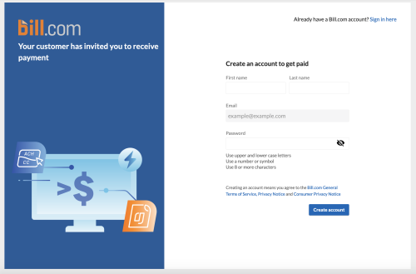

1. 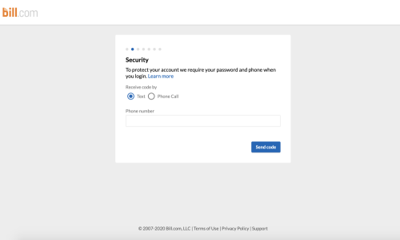Ntaus koj tus zauv xov tooj rau haum Multi-Factor Authentication (MFA) thiab tau rau **Send code**
   * Nov yog tus zauv (lej) uas peb xa rau koj txhawm kom paub tias koj yog tus nkag mus (login), ntxiv txhab nyiaj (a bank), los sis ntxiv neeg siv tshiab (users)
2. Ntaus 6 tug zauv uas peb xa tuaj rau koj thiab taum rau **Submit**  
   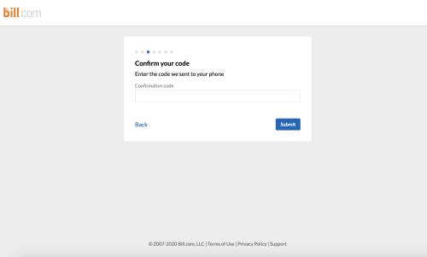
3. Xaiv seb koj tus account yog hom twg thiab taum rau **Next**  
   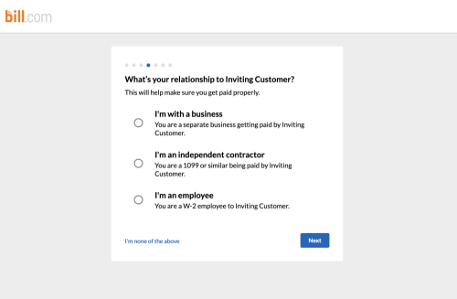
4. Ntaus koj cov qhob moos (information):
   * 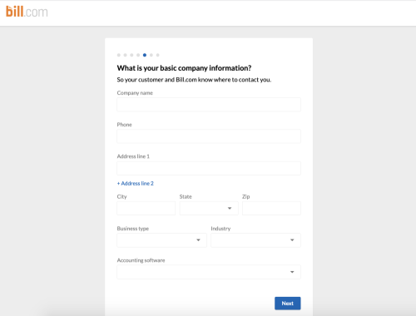Yog tias koj yog cov neeg ua lag luam, ntaus cov qhob moos ntawv koj lubb tuam txhab rau thiab taum mus rau **Next**
   * 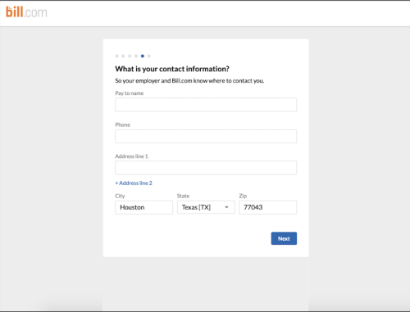Yog tias koj yog ib tug neeg ua huaj lwm (individual employee), ntaus koj cov qhob moos tag ces taum rau **Next**
5. Yog tias koj nrog cov ua lag luam (with a business), ntaus tus tswv tuam txhab cov qhob moos
   * Cov qhob moos no ua raws li kev cai ntawm tsoom fwv loj (federal compliance)  
     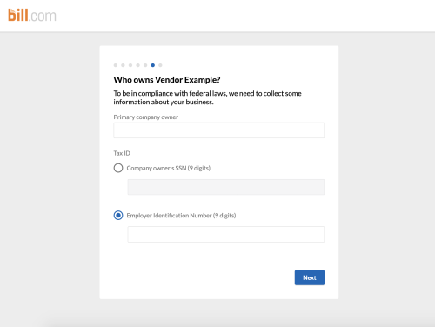
6. Ntaus koj cov qhob moos txog bank uas koj yuav siv xa them nyiaj
   * Peb yuav sim xa nyiaj nkag li $0.01 (a penny) txhawm rau (verify the account)  
     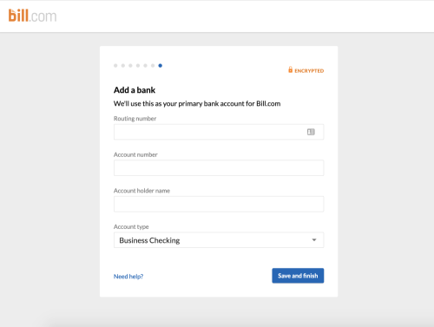

Li ntawv xwb! Koj tus account txais nyiaj (Receivables account) siv tau lawm.

**Kev Ntaus Bank Account:**

**VIDEO:** [**https://help.bill.com/hc/en-us/articles/360035752611-Video-Adding-a-bank-account-by-manual-entry**](https://help.bill.com/hc/en-us/articles/360035752611-Video-Adding-a-bank-account-by-manual-entry)

# **Kev ntaus Bank account los ntawm tus kheej**

* 1 lub hlis tom qab

 Kho tshiab (Updated)

Kev them nyiaj los sis tau nyiaj los ntawm kev siv Bill.com, koj yuav tsum tau ntaus koj tus bank account rau haum koj tus Bill.com. Txhawm rau ntaus tus bank account, koj yuav tau siv tus zauv (bank’s routing number) thiab koj tus zauv (account number).

Koj yuav tsum yog tus sau npe (signer) los sis tau txais kev tso cai txog kev tau txais thiab them nyiaj (transactions) tom tuam txhab nyiaj uas koj siv nrog rau koj tus Bill.com account

Tus neeg siv (Users) uas koj teeb tsa (assign) ua tus saib xyuas thiab them nyiaj txhawm rau kom ntxiv tau (add bank accounts). Yog tias koj tsim (custom roles) rau tus siv (account users), koj yuav tsum tau xaiv kev tso cai ntawm **Pay bills via Bill.com** txhawm rau ntxiv (add) bank accounts.

**Nkag mus saib tau nyob rau haum** [Video: Adding a bank account by manual entry](https://help.bill.com/hc/en-us/articles/360035752611-Video-Adding-a-bank-account-by-manual-entry)

## **Nkag mus ntxiv bank account los ntawm tus kheej (manually)**

1. Taum rau **Settings** nyob haum koj tus account Bill.com
2. Ntawm koj lub tuam txhab, taum **Bank Accounts**
3. Taum **Set up new bank**
4. Xaiv **Standard**
5. Ntau koj tus bank account (details) thiab taum **Continue**
6. Ua kom tiav kev tshawb xyuas (identity verification)
   * Lawv (system) yuav muaj ntau lo lug coj los nug koj (to authenticate you). Peb yuav tsis khaws cov lus teb ntawm cov lus nug no cia. Peb tsuas yog xav siv kom paub tias yog koj.
     + Yuav tsum siv koj cov qhob moos (lub npe, chaw nyob, lwm yam thiab...), peb thiaj li paub tias yog koj.
     + Txhua leej yuav tsum ua kev lees (verification) los ntawm tus kheej; tsis xav pub lwm tus tuaj loov koj.
7. Tos kev sim xa nyiaj li 1-2 hnub. Tom qab ntawv cov nyiah uas sim xa tuaj yuav nyob rau ntawm qhov yua ua (To Do List) haum bas xis (bank account).
8. Taum **the link for the bank account**
9. Ntaus cov nyiaj (deposit amount) thiab taum **Verify**
   * Yog hais tias qees yam qhob moos ntawm nej lub tuam txhab uas lawv xav tau uas nej tsis tau qhia nyob rau zaum tag los, zaum no yuav tau ua kom tiav.



## **Kev Txheeb Xyuas Tus Kheej (Identity verification)**

Yog hais tias nws tsis tuab yeem txheeb xyuas koj tus kheej tau nyob rau haum system, los sis koj tawm ntawm teb chaws Mes Kas lawm, peb yuav kom koj muab (upload) 2 – 3 yam ntaub ntawv los txheeb xyuas koj tus kheej.

Tom qab uas koj tau siv cov lus nug uas tsis siv neeg 2 zaug lawm, koj yuav tau txais tsab ntawv kom koj xa cov ntaub ntawv uas zoo ib yam nkaus li ntawm koj tus account.  
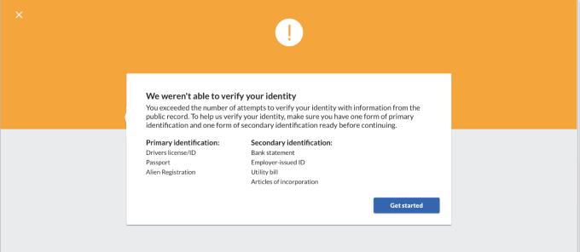

Koj kuj tuaj yeem  [taum ntawm no (click here](https://help.bill.com/hc/en-us/requests/new?ticket_form_id=360000471051)) ttxhawm rau qhib thiab xa cov ntaub ntawv.

## **Cov uas yuav tsum tau paub (Things to know)**

* Kev tshawb fawb tib neeg (Standard personal) los sis cov neeg ua lag luam (business) nyob rau ntawm lub tuam txhab nyiaj (based bank) haum US tsuas muaj ib txog huav kev no xwb thiaj li yuav txhab ntxiv (add) tau, txhawm rau them nyiaj los sis tau txais nyiaj (receive) los ntawm Bill.com. Daim npav them ua ntej (Prepaid cards), cov account siv tau thoob ntiaj teb (international bank accounts), thiab lwm yam yuav tsis tau txais kev tshawb fawb (verified).
* Peb yuav xa ib tsab ntawv rau txhua tus saib xyuas cov neeg siv (Users) haum Bill.com yog tias muaj kev txhab ntxiv tawm bank account.
* Thaum uas koj tus bank account siv tau lawm/ raug tshawb xyuas tag lawm, cov uas tau txais kev tso cai los tawm cov tuam txhab nyiaj tuab yeem muab cai rau lwm tus los them nyiaj nyob rau haum ib lub thuam txhab nyiaj.
* Nej muaj pes tsawg tus bank account nyob rau haum Bill.com los tau
* Tus neeg uas tau kev tso cai los ntawm tuam txhab nyiaj tuab yeem update the default bank txhawm rau them nyiaj thiab tuam txhab nyiaj them tuaj.

**Sijhawm Kawm Ntawm REAP**

**Tshwj Xeeb:** Cov hijhawm tej zaum kuj yuav muaj kev hloov pauv. Thov kom ua hauj lwm nrog rau koj tus Anchor CBO txhawm rau thiaj paub txog kev hloov pauv ntawm kev kawm REAP. Kev kawm kuj muaj ntau yam kev xaiv rau nej li haum qab no:

* **Kev Kawm nyob rau hnub Tuesday:** 5:30pm - 7pm
* **Kev Kawm nyob rau hnub Saturday:** 10am - 11:30am

|  |  |  |  |
| --- | --- | --- | --- |
|  | **Cov Kev Kawm**  **(Training Module)** | **Kev Xaiv 1**  (Zoo Yam li tiag “Virtual”- on Zoom) | **OPTION 2**  (Tuaj Koom – Thaj chaw yuav raug tshaj tawm) |
| 1 | **Tus Coj nrog kev Pom deb**  **(Leading with a Vision)** | Tuesday, lub Yim Hli, hnub tim 17  Thaum 5:30pm | Saturday, lub Yim Hli, hnub tim 21 thaum 10am |
| 2 | **Qhov Zoo Ntawm kev Sib Tham Tim Ntsej Tim Muag**  **(The Power of Meeting Face-to-face)** | Tuesday, lub Cuaj Hlis Hnub tim 21 thaum  5:30pm | Saturday, lub Cuaj Hlis Hnub tim 25 thaum 10am |
| 3 | **Kev Nkag Siab Txog teb chaw ntawm Fresno**  **(Understanding the Fresno Landscape)** | Tuesday, lub Kaum Hlis hnub tim 19 thaum  5:30pm | Saturday, lub Kaum Hlis hnub tim 23 thaum 10am |
| 4 | **Teeb Meem Rau Kev Ua  (Problems to Policies)** | Tuesday, lub Kaum ib Hlis Hnub tim 9, thaum 5:30pm (Quab Yuam) | |
| 5[1] | **Kev Tsim Kev Ua**  **(Forming a Policy Agenda)** | Saturday, Lub Kaum ib Hlis hnub tim 13 Thaum 10am  (Quab Yuam) | |
| **Chaw Ua Hauj Lwm Haum Zej Zog (Community Congress)** | | **Lub Kaum Ob Hlis HnubTim 10**  (Tej Zaum Kuj muaj kev hloov pauv) | |
| 6 | **Kev Npaj Ua (Planning for Action)** | Tuesday, Lub Ib Hlis hnub tim 18 thaum 5:30pm | Saturday, Lub Ib Hlis hnub tim 22  Thaum 10am |

**Tshwj Xeeb (NOTES)**

**Tshwj Xeeb (NOTES)**

1. Peb yuav npa lub Rooj Sib Tham haum Zej Zog nyob rau lub Kaum ob Hlis. Txhawm rau kom npaj tiav, peb yuav muaj 2 qhov kev kawm nyob rau lub kaum Ib Hlis.